**Payment and Cancellation Policy**

**Jess Whitehead Tuition**

Updated: September 2020

At present, tuition services are in very high demand so as a result there are terms of which you must agree to before commencing tuition to ensure fairness among clients and those waiting for spaces.

From the 1st of October 2020, sessions will be billed in sets of 5 sessions. Payment must be received by the second session. Failure to pay may result in termination of sessions and your slot may be allocated to another client.

In the event of a missed session without valid excuse, I am not obliged to reschedule sessions and you will be charged. Should you wish to arrange a session to prevent your son/daughter from missing out on learning, this will be charged independently.

In the event of cancellation with valid excuse (including illness etc), I will try my best to reschedule the session. If I am unable to, that missed session will be refunded or carried over to the next term. Please try and give at least 24 hours’ notice for cancellations, although I understand fully that in some instances that this is not possible.

Thank you very much for your understanding and cooperation.

Best Wishes,

Jess Whitehead

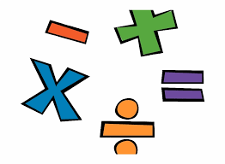

**Jess Whitehead Tuition**

**Affordable, private tuition for all ages**